Equations of Straight Lines
Line A
Line B
Line D
Line D
Line A
Line B
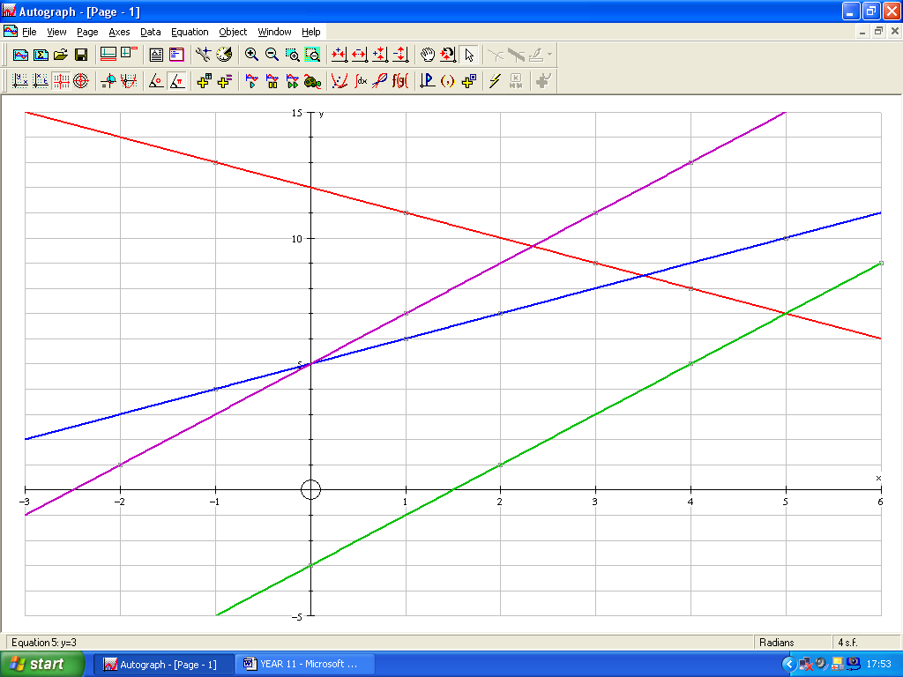
Line C

1. Four of these points lie on each of the lines A, B, C and D put the points into the correct table.

x | y |  | Line A |  |  | Line B
-2 | 1 |  | x | y |  | x | y
1 | 11
-1 | 4
4 | 5
2 | 7
3 | 9
6 | 9
1 | 7
4 | 8 |  | Line C |  |  | Line D
3 | 11 |  | x | y |  | x | y
0 | -3
5 | 10
1 | 6
2 | 1
-1 | 13
4 | 13

2. Look at the coordinates on each line and decide which of these equations goes with which line?

y = 1x + 5 y = 2x – 3 y = -1x + 12 y = 2x + 5

3. Write down the correct equation against each of the lines on the graph above.

4. Write down anything that you notice about the position and steepness of the lines and their equations.

